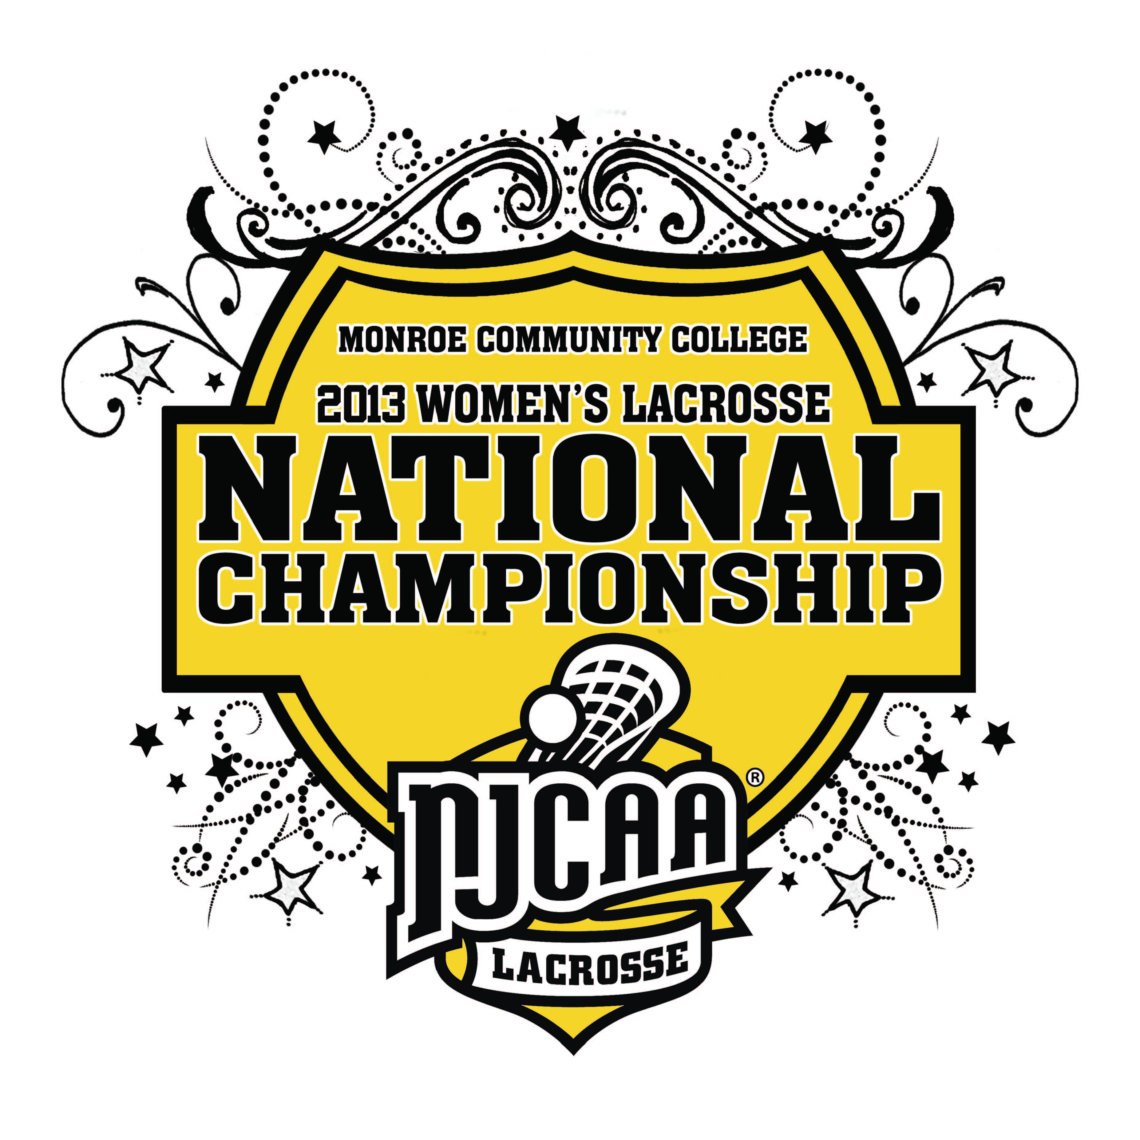

May 11-12, 2013
MONROE COMMUNITY COLLEGE
ROCHESTER, NEW YORK
2013 NJCAA WOMEN’S LACROSSE NATIONAL CHAMPIONSHIP

Tournament Site: John L. DiMarco Field
Monroe Community College
1000 E. Henrietta Road
Rochester, NY 14623

Dates: May 11-12, 2013

Tournament Contacts: Dudley “Skip” Bailey
Director of Athletics
Office: (585) 292-2833
dbailey@monroecc.edu
Fax: (585) 292-3845

Tim Parrinello
Assistant Athletic Director
Office: (585) 292-2837
tparrinello@monroecc.edu

Tom Garigen
Assistant Athletic Director/SID
Office: (585) 292-2834
tgarigen@monroecc.edu

Tournament Website: Game recaps and other information will be posted on MCC’s website. The tournament’s site can be found by going to http://www.mcctribunes.com and scrolling over the “Inside Athletics” tab.

Roster/Photos/Logos: Please e-mail a team photo in color, team logo, and rosters (using the enclosed form) as attachments to Tom Garigen at tgarigen@monroecc.edu by Wednesday, May. 1. Please send this information even if you are unsure you have qualified for the tournament. Submit all photos by using the following specifications:

Team Photo (in color)
- .TIF or .JPG file format
- 300 dpi resolution
Team and Mascot Logos
- .TIF, .JPG or EPS file format
- 300 dpi resolution (or EPS vector)
Lodging: Lodging is available at one of the two hotels listed below. Contact information is below as well. Recommended hotels are listed below.

Best Western Residence Inn
Contact: Keni Patel Contact: Chrystie Baker
940 Jefferson Road 1300 Jefferson Road
Rochester, NY 14623 Rochester, NY 14623
Phone: (585) 427-2700 Phone: (585) 272-88f0

A block of rooms are on reserve under MCC Women’s Lacrosse Tournament. The rate is $89 per night for the Best Western and $179 per night for a suite that holds five at the Residence Inn. Rooms are being held until May 4, 2012. In order to receive the rate, you must book by this date.

T-Shirts: An order form for tournament apparel will come separately.

Banquet: The team banquet will be on Friday, May 10 from 5:30-7:30 p.m. in the R. Thomas Flynn Campus Center at Monroe Community
College. The order form is included in this packet. Tickets are $10 per attendee.

Gift Exchange: Please bring enough items for a team gift exchange with another participating team.

NJCAA Coaches Meeting: The NJCAA Women’s Lacrosse Coaches Meeting will take place on Friday, May 10, immediately after the team banquet. It will be held in MCC’s PAC Conference Room.

Practice Assignments: Please contact MCC Director of Athletics Skip Bailey to schedule a practice time for Friday. Contact him at dbailey@monroecc.edu or (585) 292-2833.

Uniforms and Locker Rooms: Uniform and locker room assignments will be discussed at the coaches meeting Friday evening.

Athletic Trainers: An athletic trainer will be available during the entire tournament, including practices. Each participating team must provide its own medical kit and training supplies. An overview of what is being offered is included in this document.

Ticket Prices: General Admission: $5 Per Day

Children 14 and under: FREE

Each team will receive tournament passes based upon their official roster. The pass must be displayed at all times to gain entry. Each player and coach will receive a complimentary program.

Programs: Additional programs may be purchased for $2 each.

Rules and Guidelines: The 2013 NJCAA Women’s Lacrosse Tournament will run in accordance with the NJCAA rules and regulations and NCAA playing rules.

Official Scorebook: The official scorebook will be kept by Monroe Community College. Competing teams may keep their own, but those sheets are unofficial.

Hospitality Room: A hospitality room for coaches, college personnel, media and staff will be in the PAC Center Conference Room. You must show your tournament pass to gain entrance to the room.

Awards: There will be an awards ceremony immediately following the Championship Game. Awards presented will include the
Champion and Runner-up trophies, plus individual medals for the winning and runner-up team. Other awards include Coach of the Tournament, Best Offensive and Defensive Player, and All-Tournament team consisting of 12 players

Tournament Schedule
2013 NJCAA Women’s Lacrosse National Championship

Tournament Format: The NJCAA Women’s Lacrosse Classic will be a four-team, single-elimination tournament. Participating teams for this tournament will come from four districts: District A (Region 3, 21 Champion), District B (Region 20, 15, 19 Champion), District C (Region 3, 21 Runner-up), and District D (Region 20, 15, 19 Runner-up). In the event a team decides not to participate, the Women’s Lacrosse Committee will select an At-Large team.

Friday, May 10th:

Team Banquet:
The team banquet will take place Friday at 5:30 p.m. in the R. Thomas Flynn Campus Center on the MCC campus. Please fill out the banquet order form in this packet.

Coaches Meeting:
There will be a mandatory tournament and coaches meeting following the team banquet in Monroe Community College’s PAC Center Conference Room.

Saturday, May 11th:
Game 1: 11 a.m. District B vs. District C

Game 2: 1:30 p.m. District A vs. District D

Sunday, May 12th:
Championship: 1 p.m. Winner Game 1 vs. Winner Game 2

Award Ceremony: Following the Championship Game

***PLEASE BRING BOTH SETS OF UNIFORMS TO THE TOURNAMENT***

IMPORTANT DATES AND DEADLINES
2013 NJCAA Women’s Lacrosse National Championship

WEDNESDAY, MAY 1

Intent to Compete Form

Roster/Team Information Form Due

Team Photo Due (color 300 dpi)

College Mascot/Logo Due
(color 300 dpi)

Banquet Reservation/Media Form Due

DECLARATION OF INTENT TO COMPETE
2013 NJCAA Women’s Lacrosse National Championship

__________________________: Wishes to be considered for selection and seeding into
(College Name) the NJCAA Women’s Lacrosse National Tournament.

Signed:_______________________________________
ATHLETIC DIRECTOR

Signed:________________________________________
HEAD COACH

Date:__________________________________________

______________________________: Does not wish to be considered for the selection and seeding
Into the NJCAA Women’s Lacrosse National Tournament.

Signed:_______________________________________
ATHLETIC DIRECTOR

Signed:________________________________________
HEAD COACH

Date:__________________________________________

Please FAX this form by WEDNESDAY, MAY 1st to:

Skip Bailey, Director of Athletics
FAX: (585) 292-3845
Email: dbailey@monroecc.edu

OFFICIAL ROSTER FORM (Due Wednesday, May 1)
2013 NJCAA Women’s Lacrosse National Championship

College:
School Mascot/Nickname:
School Colors:

#  (H/A) | Name | Yr. | Pos. | Ht.  (ex. 6-0) | Hometown  (city, state) | High School

Head Coach:
Assistant Coaches:
Athletic Director:
Athletic Trainer:
Other Personnel Requiring Credentials:

BANQUET ORDER FORM (Due Wednesday, May 1)
2013 NJCAA Women’s Lacrosse National Championship

Monroe Community College will host a banquet on Friday, May 10 in the R. Thomas Flynn Campus Center on the MCC campus. The banquet will begin with a reception at 5:30 p.m. and a guest speaker at 6 p.m., with dinner to follow. The banquet cost is $10 per ticket.

College Name:

Number Attending: x $10.00 per ticket

Total Amount included:

Banquet Notes:
- Attire: Please dress for a semi-formal event. No jeans.
- Gift bags will be presented to each player and coach in attendance
- Please make checks payable to “MCC Association, Inc.”
- Send checks to: Skip Bailey, Director of Athletics
Monroe Community College
1000 E. Henrietta Road
Rochester, NY 14623

MEDIA INFORMATION (Due Wednesday, May 1)
2013 NJCAA Women’s Lacrosse National Championship

Please fill out and return this media information if you would like our staff to send scores and game recaps as the tournament is in progress.

College Name: ______________________________________________

Head Coach: ________________________________________________

Media Name Fax Number E-Mail
____________________________________ (______) ______-_________
____________________________________ (______) ______-_________
____________________________________ (______) ______-_________

Please only list three media outlets. Thank You!!
Athletic Training Coverage
2013 NJCAA Women’s Lacrosse National Championship

A certified athletic trainer will be available for treatment of athletic injuries. If you are traveling without a certified athletic trainer and have an athlete who needs treatment, she may utilize the athletic trainer onsite during the tournament.

Any injured athlete needing treatment must provide the athletic trainer with a written diagnosis and treatment protocol for the injury.

Athletes who obtain injuries during tournament will be evaluated and treated in accordance with New York State law.

Note: For any certified athletic trainer traveling with the team, we will have ice, moist heat, ultrasound and electrical stimulation modalities available for use. Water coolers will also be available.

Each team will be responsible for bringing its own taping supplies.

Training Room Hours:

Saturday, May 11, 2013
9 a.m. through the end of the second game

Sunday, May 12, 2013
11 a.m. until the end of game

Important phone numbers:
Mike Cerame MS, ATC
Head Athletic Trainer
Office: (585)-292-2857
Cell: (585)-490-1096

Mary Salluzzo MS, ATC
Asst. Athletic Trainer
Office: (585)-292-2850

University of Rochester Medical Center
Strong Memorial Hospital
601 Elmwood Avenue
Emergency Dept # 585-273-4041

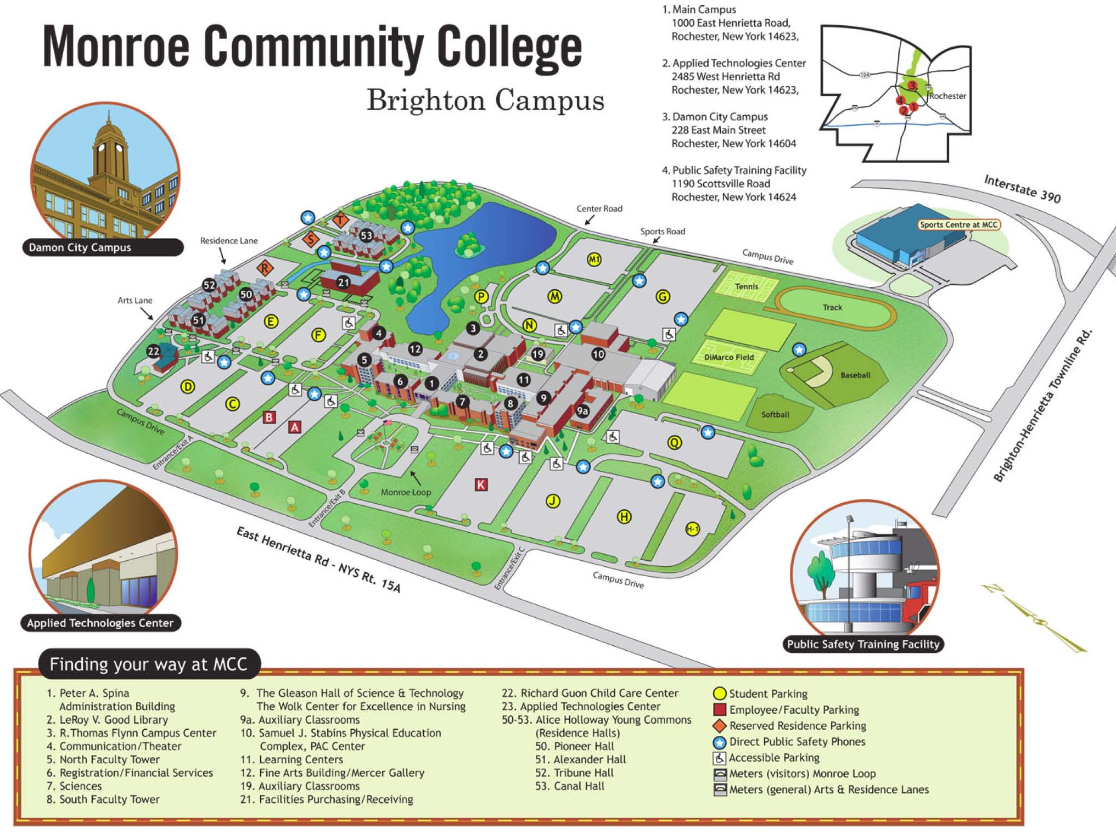

MCC Brighton Campus | 1000 East Henrietta Road  Rochester, NY 14623  585-292-2000
To reach the MCC Brighton Campus from:
The West (Buffalo) | Take Thruway 90 east to exit 46; take 390 north to exit 16, the second East Henrietta Rd. (Rt. 15A) exit; turn left and continue south on 15A for about 1/2 mile to the main campus entrance.
The East (Syracuse) | Take Thruway 90 west to exit 46 and proceed as above.
South (Geneseo) | Take 390 north to exit 16 - the second East Henrietta Road exit and proceed as above.
Brockport/Spencerport | Take Route 531 east to 490 east and then to 390 south; take exit 16B (East Henrietta Rd. - Rt. 15A); turn right and proceed for about 1/2 mile to the main campus.

